Turn ‘Dog’ into ‘Pet’

Start with the word ‘DOG’
Change one letter at a time to change ‘DOG’ into ‘PET’

DOG
Change one letter and get a word that means a period at the end of a sentence.
_ _ _

Change one letter and get a word that means something that you cook in.
_ _ _

Change one letter and get a word that means an animal that you take care of in your home.

PET You did it!

Name the dog in the picture—can you find her in the book, NAME THAT DOG?

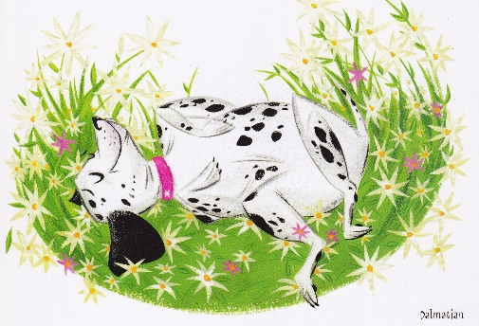
Turn ‘Dog’ into ‘Pet’

Start with the word ‘DOG’
Change one letter at a time to change ‘DOG’ into ‘PET’

DOG Change one letter and get a word that means a period at the end of a sentence.
DO _

DOT Change one letter and get a word that means something that you cook in.
_ OT

POT
P _ T Change one letter and get a word that means an animal that you keep at home.

PET You did it!

Name the dog in the picture—can you find her in the book, NAME THAT DOG?

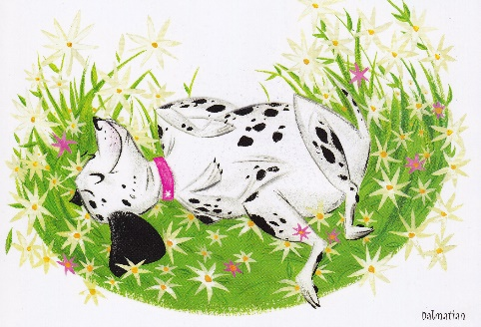

Answer:

Turn a Dog into a Pet in 3 easy steps!

Start with the word ‘DOG’
Change one letter at a time to change ‘DOG’ into ‘PET’

DOG Change one letter and get a word that means a period at the end of a sentence.

DOT Change one letter and get a word that means something that you cook in.

POT Change one letter and get a word that means an animal that you keep at home.

PET You did it!

illustration by Stephanie Buscema
NAME THAT DOG!
by Peggy Archer
Dial Books for Young Readers 2010

