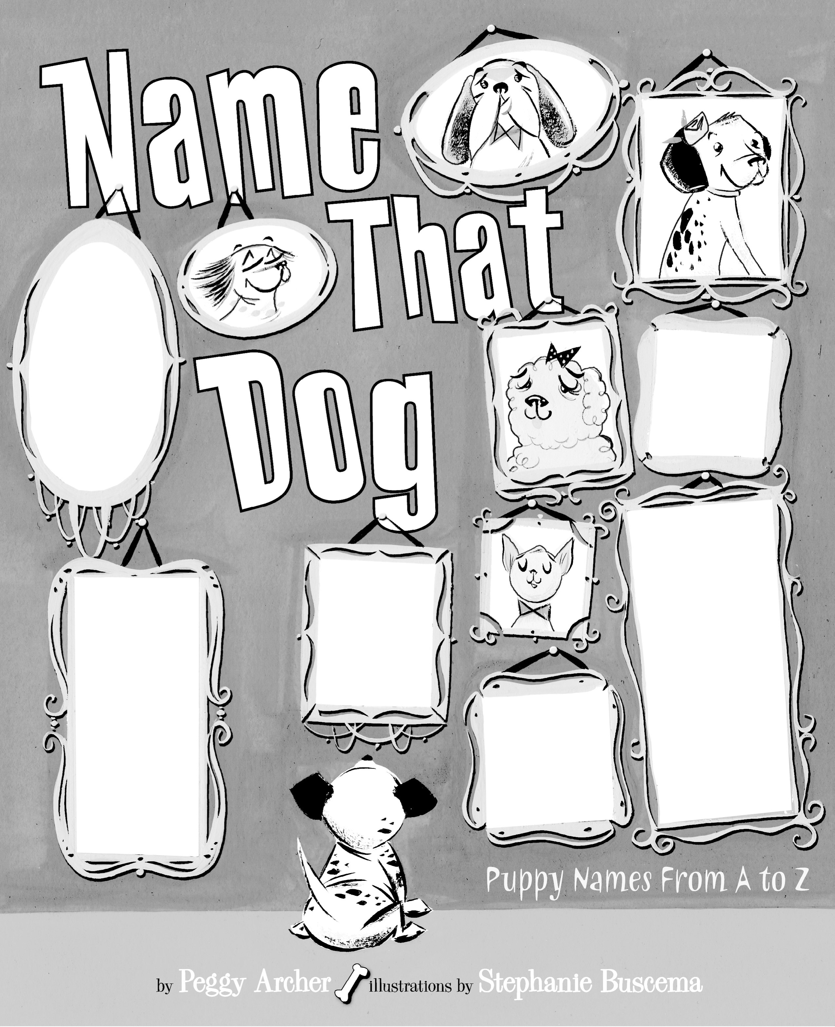
Dial Books for Young Readers H a division of Penguin Young Readers Group 345 Hudson Street H New York, NY 10014

